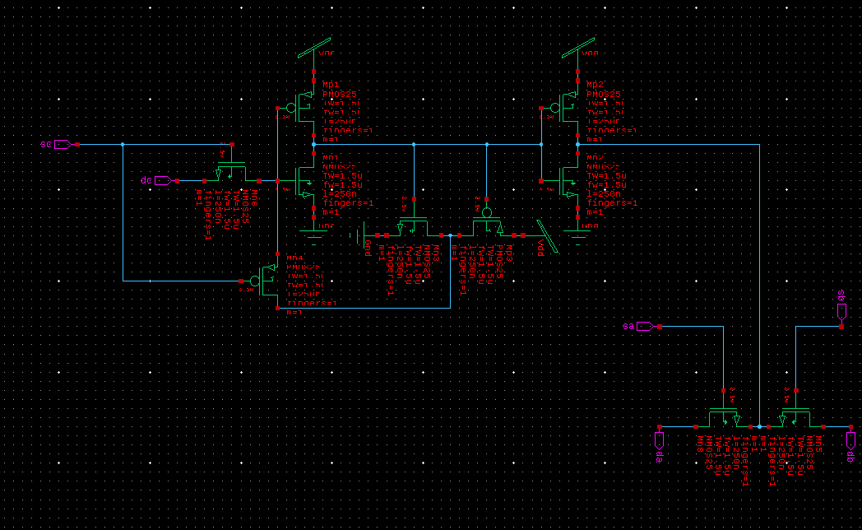
Schematic of the Register Cell

This is the S-Edit schematic of the register cell. I did not include any voltage sources here until later because they would affect LVS and PEX. For the later simulations, I used vbit to set specific patterns for the inputs sc, dc, sa, and sb, and V_VoltagePrint to see the waveforms in the waveform viewer.

SPICE net-list
Using T-Spice, I got my .sp file and I have copy and pasted my spice netlist below:

* SPICE export by: S-Edit 2022.2.2
* Export time: Wed Oct 22 10:55:00 2025
* Design path: /home/eky9/ECSE485/Labs/lib.defs
* Library: Labs
* Cell: lab2_redo
* Testbench: Spice
* View: schematic1
* Export as: top-level cell
* Export mode: hierarchical
* Exclude empty: yes
* Exclude .model: no
* Exclude .hdl: no
* Exclude .end: no
* Expand paths: yes
* Wrap lines: no
* Exclude simulator commands: no
* Exclude global pins: no
* Exclude instance locations: no
* Control property name(s): SPICE

********* Simulation Settings - General Section *********
***** Top Level *****
XMn1 N_2 N_3 Gnd Gnd NMOS25 w=1.5u l=250n m=1 ad=975f pd=4.3u as=975f ps=4.3u nrd=433.33333m nrs=433.33333m mult=1 delvto=0 mulu0=1 $ $x=3600 $y=5100 $w=400 $h=600
XMn2 N_4 N_2 Gnd Gnd NMOS25 w=1.5u l=250n m=1 ad=975f pd=4.3u as=975f ps=4.3u nrd=433.33333m nrs=433.33333m mult=1 delvto=0 mulu0=1 $ $x=6500 $y=5100 $w=400 $h=600
XMn3 N_1 N_2 Gnd Gnd NMOS25 w=1.5u l=250n m=1 ad=975f pd=4.3u as=975f ps=4.3u nrd=433.33333m nrs=433.33333m mult=1 delvto=0 mulu0=1 $ $x=4900 $y=4700 $w=600 $h=400 $r=90
XMn5 db sb N_4 Gnd NMOS25 w=1.5u l=250n m=1 ad=975f pd=4.3u as=975f ps=4.3u nrd=433.33333m nrs=433.33333m mult=1 delvto=0 mulu0=1 $ $x=9100 $y=2600 $w=600 $h=400 $r=90
XMn6 N_3 sc dc Gnd NMOS25 w=1.5u l=250n m=1 ad=975f pd=4.3u as=975f ps=4.3u nrd=433.33333m nrs=433.33333m mult=1 delvto=0 mulu0=1 $ $x=2900 $y=5300 $w=600 $h=400 $r=90
XMn8 da sa N_4 Gnd NMOS25 w=1.5u l=250n m=1 ad=975f pd=4.3u as=975f ps=4.3u nrd=433.33333m nrs=433.33333m mult=1 delvto=0 mulu0=1 $ $x=8300 $y=2600 $w=600 $h=400 $r=90 $m
XMp1 N_2 N_3 Vdd Vdd PMOS25 w=1.5u l=250n m=1 ad=975f pd=4.3u as=975f ps=4.3u nrd=433.33333m nrs=433.33333m mult=1 delvto=0 mulu0=1 $ $x=3600 $y=5900 $w=400 $h=600
XMp2 N_4 N_2 Vdd Vdd PMOS25 w=1.5u l=250n m=1 ad=975f pd=4.3u as=975f ps=4.3u nrd=433.33333m nrs=433.33333m mult=1 delvto=0 mulu0=1 $ $x=6500 $y=5900 $w=400 $h=600
XMp3 N_1 N_2 Vdd Vdd PMOS25 w=1.5u l=250n m=1 ad=975f pd=4.3u as=975f ps=4.3u nrd=433.33333m nrs=433.33333m mult=1 delvto=0 mulu0=1 $ $x=5700 $y=4700 $w=600 $h=400 $r=90
XMp4 N_1 sc N_3 Vdd PMOS25 w=1.5u l=250n m=1 ad=975f pd=4.3u as=975f ps=4.3u nrd=433.33333m nrs=433.33333m mult=1 delvto=0 mulu0=1 $ $x=3200 $y=4000 $w=400 $h=600

********* Simulation Settings - Analysis Section *********

********* Simulation Settings - Additional SPICE Commands *********

.end

Simulation waveforms
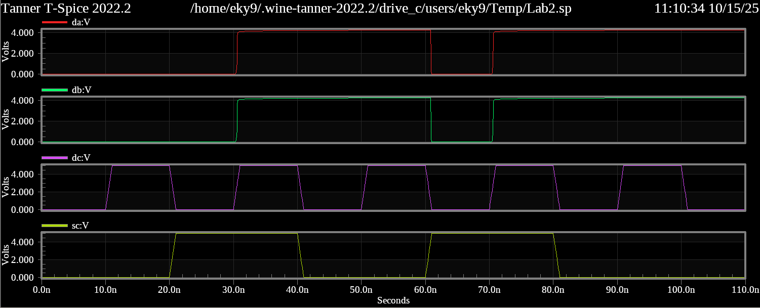
sa and sb both high:

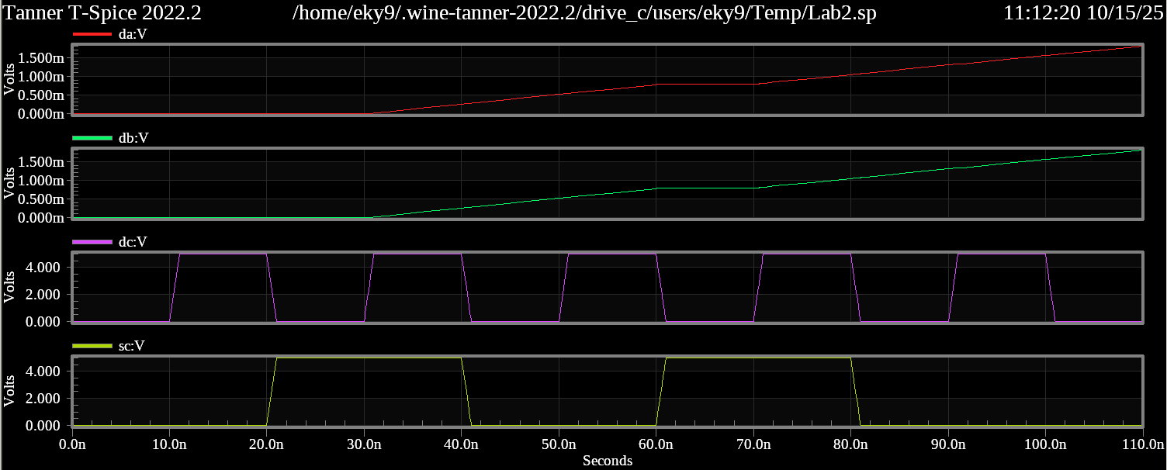
sa and sb both low:

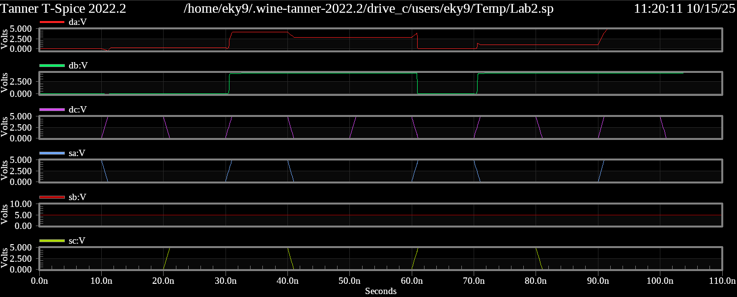
Only sb high:

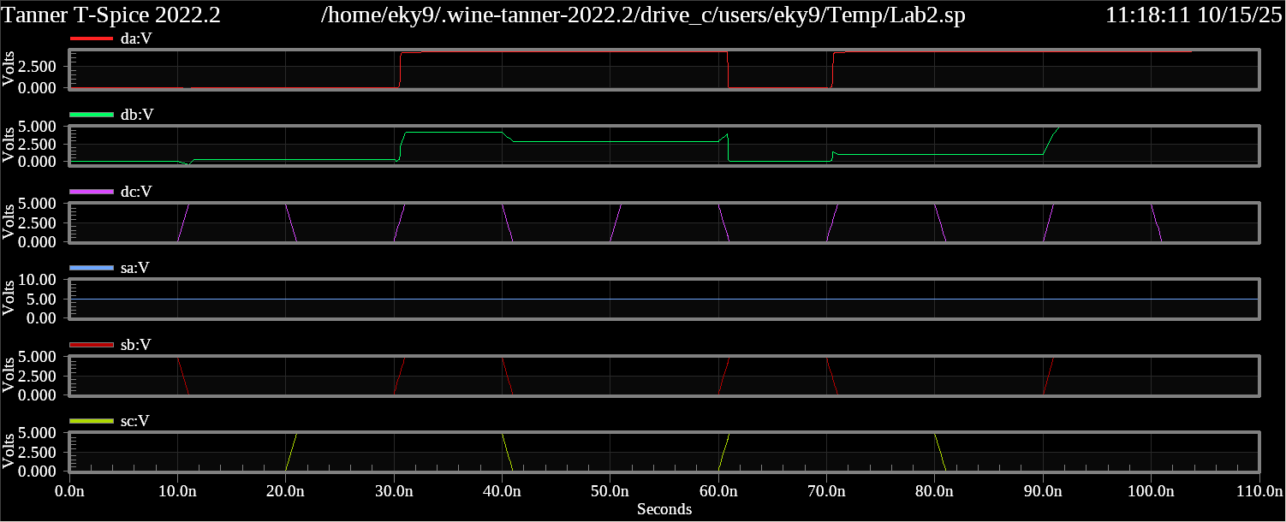
Only sa high:

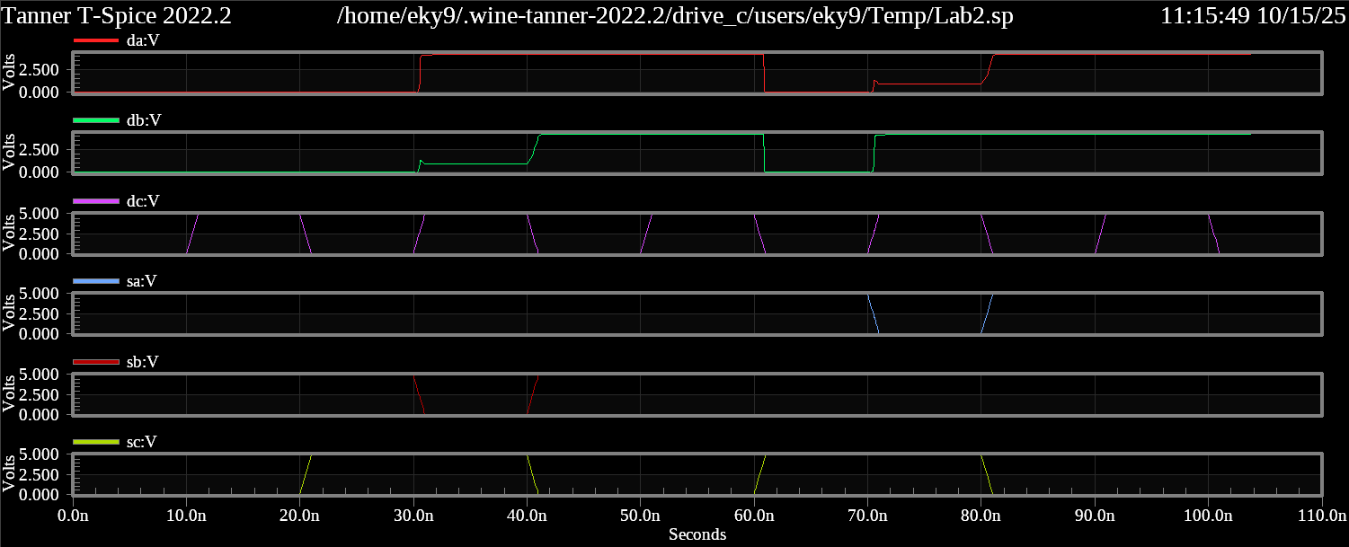
sa and sb alternate:

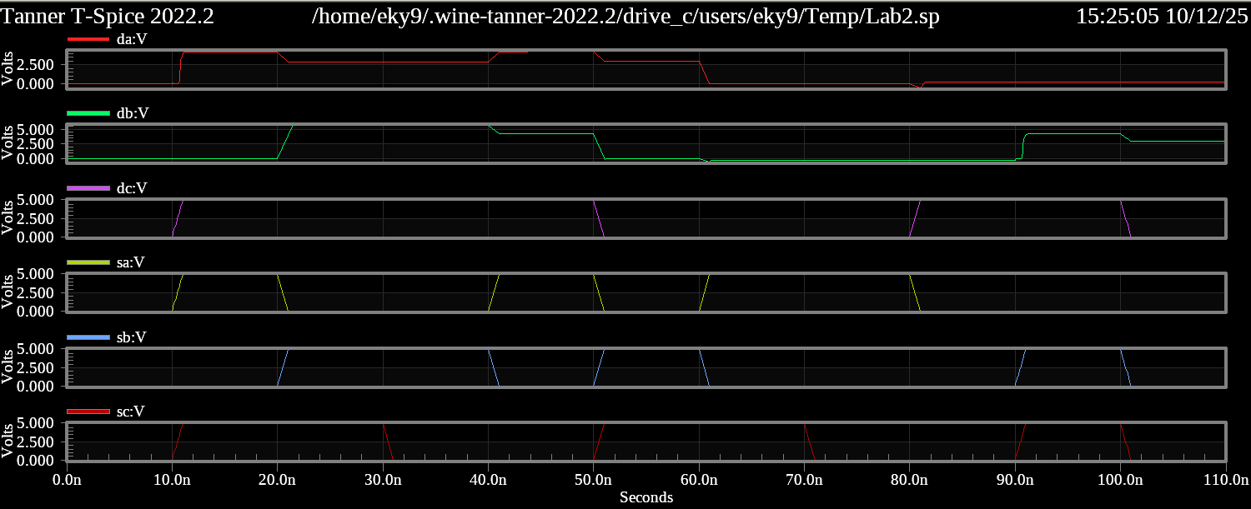
Random input waveform:

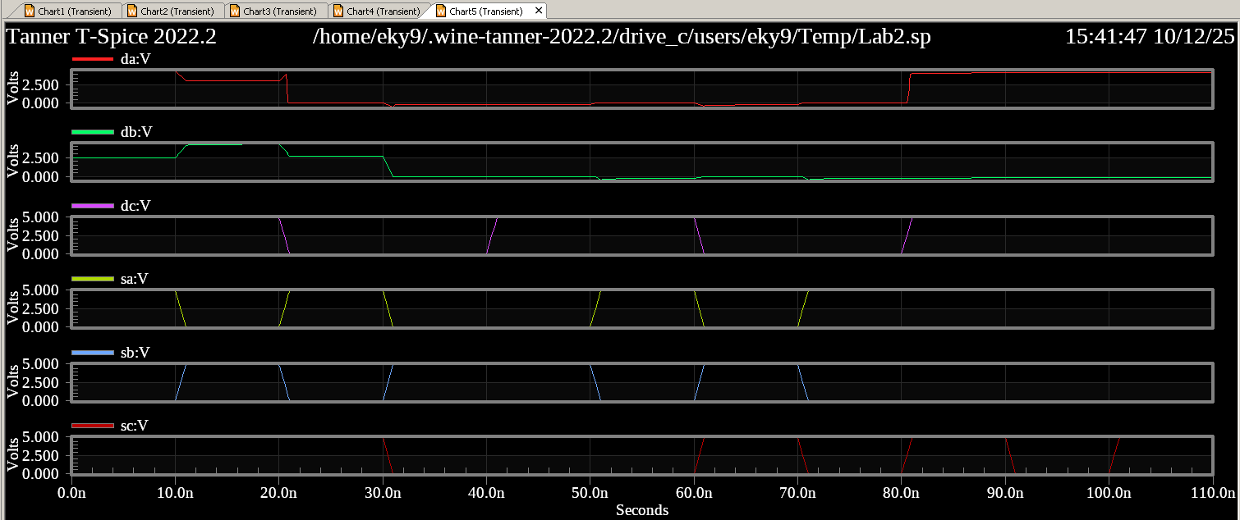
Random waveform 2:

Later in the lab report, I will also show these same simulations with the data collected from PEX to show how the waveforms differ when taking parasitic capacitance into account.

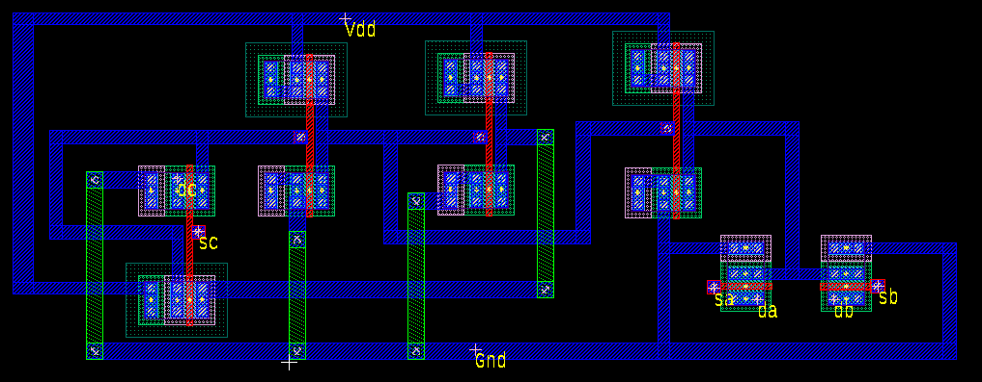
Final layout of the register cell

This is my final layout in L-Edit that passed DRC, LVS, and PEX. My Vdd rail is on the top and Gnd Rail is on the bottom, and I needed to use some Metal2 in order to connect everything properly.

Calibre Setup
To setup for Calibre DRC, LVS, and PEX, I enabled DRC, LVS, PEX, and PERC in the Calibre Setup tool and set all their values to 1 so I could use the newer graphics, as explained in the Tanner L-Edit User’s Manual. From there, I needed to select each file for their respective tests in the “Rules” folder in TannerEDA.

Calibre Reports for DRC, LVS, and PEX

DRC Summary
For starters, I ran DRC and saw the following pop-up windows:
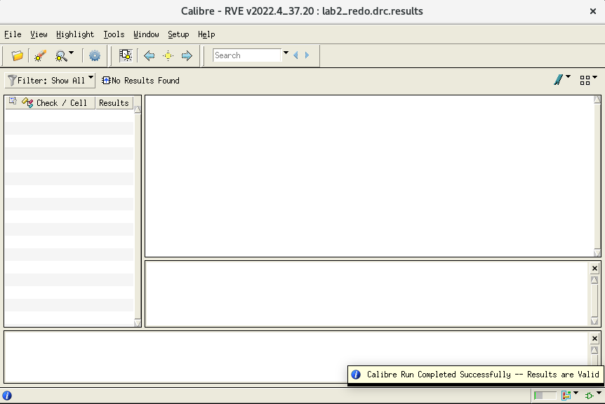

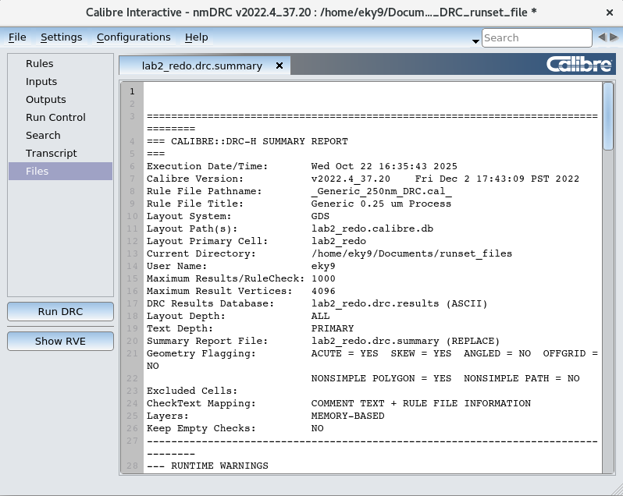

I have copied and pasted the full DRC Summary that was provided, below:

==================================================================================
=== CALIBRE::DRC-H SUMMARY REPORT
===
Execution Date/Time: Wed Oct 22 16:27:17 2025
Calibre Version: v2022.4_37.20 Fri Dec 2 17:43:09 PST 2022
Rule File Pathname: _Generic_250nm_DRC.cal_
Rule File Title: Generic 0.25 um Process
Layout System: GDS
Layout Path(s): lab2_redo.calibre.db
Layout Primary Cell: lab2_redo
Current Directory: /home/eky9/Documents/runset_files
User Name: eky9
Maximum Results/RuleCheck: 1000
Maximum Result Vertices: 4096
DRC Results Database: lab2_redo.drc.results (ASCII)
Layout Depth: ALL
Text Depth: PRIMARY
Summary Report File: lab2_redo.drc.summary (REPLACE)
Geometry Flagging: ACUTE = YES SKEW = YES ANGLED = NO OFFGRID = NO
NONSIMPLE POLYGON = YES NONSIMPLE PATH = NO
Excluded Cells:
CheckText Mapping: COMMENT TEXT + RULE FILE INFORMATION
Layers: MEMORY-BASED
Keep Empty Checks: NO
----------------------------------------------------------------------------------
--- RUNTIME WARNINGS
---
----------------------------------------------------------------------------------
--- ORIGINAL LAYER STATISTICS
---
LAYER PImplant ........ TOTAL Original Geometry Count = 2 (10)
LAYER NImplant ........ TOTAL Original Geometry Count = 2 (10)
LAYER Poly ............ TOTAL Original Geometry Count = 15 (31)
LAYER Active .......... TOTAL Original Geometry Count = 4 (20)
LAYER ResistorID ...... TOTAL Original Geometry Count = 0 (0)
LAYER DeepNWell ....... TOTAL Original Geometry Count = 0 (0)
LAYER Contact ......... TOTAL Original Geometry Count = 18 (66)
LAYER ThickActive ..... TOTAL Original Geometry Count = 0 (0)
LAYER TCP ............. TOTAL Original Geometry Count = 0 (0)
LAYER Via3 ............ TOTAL Original Geometry Count = 0 (0)
LAYER SilicideBlock ... TOTAL Original Geometry Count = 0 (0)
LAYER Passivation ..... TOTAL Original Geometry Count = 0 (0)
LAYER Metal4 .......... TOTAL Original Geometry Count = 0 (0)
LAYER Metal1 .......... TOTAL Original Geometry Count = 67 (115)
LAYER NWell ........... TOTAL Original Geometry Count = 1 (4)
LAYER Metal2 .......... TOTAL Original Geometry Count = 12 (12)
LAYER Metal3 .......... TOTAL Original Geometry Count = 0 (0)
LAYER PWell ........... TOTAL Original Geometry Count = 0 (0)
LAYER Via1 ............ TOTAL Original Geometry Count = 8 (8)
LAYER Via2 ............ TOTAL Original Geometry Count = 0 (0)
----------------------------------------------------------------------------------
--- RULECHECK RESULTS STATISTICS
---
RULECHECK NW.SD ......... TOTAL Result Count = 0 (0)
RULECHECK NW.FS ......... TOTAL Result Count = 0 (0)
RULECHECK NW.W .......... TOTAL Result Count = 0 (0)
RULECHECK NW.S .......... TOTAL Result Count = 0 (0)
RULECHECK DNW.W ......... TOTAL Result Count = 0 (0)
RULECHECK DNW.S ......... TOTAL Result Count = 0 (0)
RULECHECK DNW.SNW ....... TOTAL Result Count = 0 (0)
RULECHECK NW.ODNW ....... TOTAL Result Count = 0 (0)
RULECHECK NW.XDNW ....... TOTAL Result Count = 0 (0)
RULECHECK PW.W .......... TOTAL Result Count = 0 (0)
RULECHECK PW.S .......... TOTAL Result Count = 0 (0)
RULECHECK NIm.S ......... TOTAL Result Count = 0 (0)
RULECHECK PIm.S ......... TOTAL Result Count = 0 (0)
RULECHECK NIm.W ......... TOTAL Result Count = 0 (0)
RULECHECK PIm.W ......... TOTAL Result Count = 0 (0)
RULECHECK Im.NP ......... TOTAL Result Count = 0 (0)
RULECHECK Im.XAc ........ TOTAL Result Count = 0 (0)
RULECHECK Ac.W .......... TOTAL Result Count = 0 (0)
RULECHECK Ac.S .......... TOTAL Result Count = 0 (0)
RULECHECK Ac.SPW ........ TOTAL Result Count = 0 (0)
RULECHECK Ac.SNW ........ TOTAL Result Count = 0 (0)
RULECHECK Ac.SCW ........ TOTAL Result Count = 0 (0)
RULECHECK Ac.SSCW ....... TOTAL Result Count = 0 (0)
RULECHECK Ac.AcIm ....... TOTAL Result Count = 0 (0)
RULECHECK ThAc.O ........ TOTAL Result Count = 0 (0)
RULECHECK Ac.XP ......... TOTAL Result Count = 0 (0)
RULECHECK Ac.XSb ........ TOTAL Result Count = 0 (0)
RULECHECK ThAc.W ........ TOTAL Result Count = 0 (0)
RULECHECK ThAc.S ........ TOTAL Result Count = 0 (0)
RULECHECK ThAc.SAc ...... TOTAL Result Count = 0 (0)
RULECHECK Po.W .......... TOTAL Result Count = 0 (0)
RULECHECK Po.WHV ........ TOTAL Result Count = 0 (0)
RULECHECK Po.S .......... TOTAL Result Count = 0 (0)
RULECHECK Po.SPAc ....... TOTAL Result Count = 0 (0)
RULECHECK Po.XAc ........ TOTAL Result Count = 0 (0)
RULECHECK Po.SAc ........ TOTAL Result Count = 0 (0)
RULECHECK Po.XSb ........ TOTAL Result Count = 0 (0)
RULECHECK Co.W .......... TOTAL Result Count = 0 (0)
RULECHECK Co.S .......... TOTAL Result Count = 0 (0)
RULECHECK Co.SG ......... TOTAL Result Count = 0 (0)
RULECHECK Co.EPo ........ TOTAL Result Count = 0 (0)
RULECHECK Co.EAc ........ TOTAL Result Count = 0 (0)
RULECHECK Co.EIm ........ TOTAL Result Count = 0 (0)
RULECHECK Co.AcGt ....... TOTAL Result Count = 0 (0)
RULECHECK M1.W .......... TOTAL Result Count = 0 (0)
RULECHECK M1.S .......... TOTAL Result Count = 0 (0)
RULECHECK M1.SW ......... TOTAL Result Count = 0 (0)
RULECHECK M1.SL ......... TOTAL Result Count = 0 (0)
RULECHECK M1.V1 ......... TOTAL Result Count = 0 (0)
RULECHECK V1.W .......... TOTAL Result Count = 0 (0)
RULECHECK V1.S .......... TOTAL Result Count = 0 (0)
RULECHECK M2.W .......... TOTAL Result Count = 0 (0)
RULECHECK M2.S .......... TOTAL Result Count = 0 (0)
RULECHECK M2.SW ......... TOTAL Result Count = 0 (0)
RULECHECK M2.SL ......... TOTAL Result Count = 0 (0)
RULECHECK M2.V1 ......... TOTAL Result Count = 0 (0)
RULECHECK M2.V2 ......... TOTAL Result Count = 0 (0)
RULECHECK V2.W .......... TOTAL Result Count = 0 (0)
RULECHECK V2.S .......... TOTAL Result Count = 0 (0)
RULECHECK M3.W .......... TOTAL Result Count = 0 (0)
RULECHECK M3.S .......... TOTAL Result Count = 0 (0)
RULECHECK M3.SW ......... TOTAL Result Count = 0 (0)
RULECHECK M3.SL ......... TOTAL Result Count = 0 (0)
RULECHECK M3.V2 ......... TOTAL Result Count = 0 (0)
RULECHECK M3.V3 ......... TOTAL Result Count = 0 (0)
RULECHECK V3.W .......... TOTAL Result Count = 0 (0)
RULECHECK V3.S .......... TOTAL Result Count = 0 (0)
RULECHECK M4.W .......... TOTAL Result Count = 0 (0)
RULECHECK M4.S .......... TOTAL Result Count = 0 (0)
RULECHECK M4.SW ......... TOTAL Result Count = 0 (0)
RULECHECK M4.SL ......... TOTAL Result Count = 0 (0)
RULECHECK M4.V3 ......... TOTAL Result Count = 0 (0)
RULECHECK M4.EP ......... TOTAL Result Count = 0 (0)
RULECHECK Pad.SM4 ....... TOTAL Result Count = 0 (0)
RULECHECK Pad.SM3 ....... TOTAL Result Count = 0 (0)
RULECHECK Pad.SM2 ....... TOTAL Result Count = 0 (0)
RULECHECK Pad.SM1 ....... TOTAL Result Count = 0 (0)
RULECHECK Pad.SPo ....... TOTAL Result Count = 0 (0)
RULECHECK Pad.SAc ....... TOTAL Result Count = 0 (0)
RULECHECK Sb.W .......... TOTAL Result Count = 0 (0)
RULECHECK Sb.S .......... TOTAL Result Count = 0 (0)
RULECHECK Sb.SCo ........ TOTAL Result Count = 0 (0)
RULECHECK Sb.SAc ........ TOTAL Result Count = 0 (0)
RULECHECK Sb.SPo ........ TOTAL Result Count = 0 (0)
RULECHECK Sb.WPo ........ TOTAL Result Count = 0 (0)
RULECHECK Sb.SRes ....... TOTAL Result Count = 0 (0)
RULECHECK Sb.EPo ........ TOTAL Result Count = 0 (0)
RULECHECK Sb.EAc ........ TOTAL Result Count = 0 (0)
RULECHECK Sb.SGate ...... TOTAL Result Count = 0 (0)
RULECHECK Pass.W ........ TOTAL Result Count = 0 (0)
RULECHECK M1Gt.A ........ TOTAL Result Count = 0 (0)
RULECHECK PoM1Gt.A ...... TOTAL Result Count = 0 (0)
RULECHECK PoM1Gt.AMPo ... TOTAL Result Count = 0 (0)
RULECHECK PoM1Gt.AMM1 ... TOTAL Result Count = 0 (0)
RULECHECK PoM1Gt.AM ..... TOTAL Result Count = 0 (0)
RULECHECK PoM1Gt.ANd1 ... TOTAL Result Count = 0 (0)
RULECHECK PoM1Gt.ANd2 ... TOTAL Result Count = 0 (0)
----------------------------------------------------------------------------------
--- RULECHECK RESULTS STATISTICS (BY CELL)
---
----------------------------------------------------------------------------------
--- SUMMARY
---
TOTAL CPU Time: 0
TOTAL REAL Time: 0
TOTAL Original Layer Geometries: 129 (276)
TOTAL DRC RuleChecks Executed: 97
TOTAL DRC Results Generated: 0 (0)

LVS Report
Next, I ran LVS and saw the following pop-up windows:
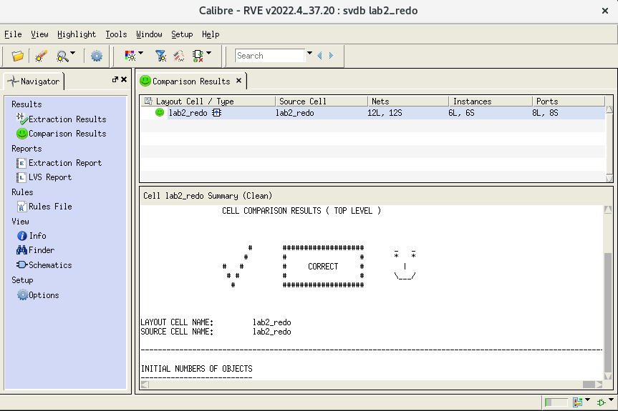

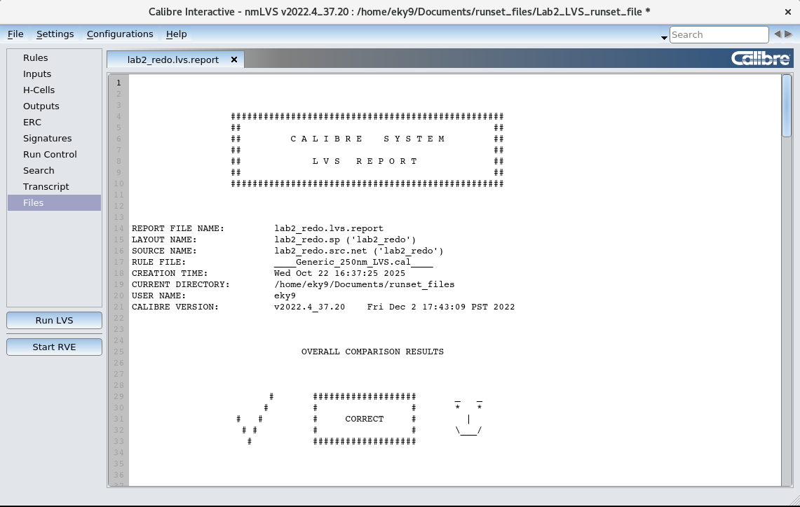

I have copied and pasted the full LVS Report that was provided, below:

##################################################
## ##
## C A L I B R E S Y S T E M ##
## ##
## L V S R E P O R T ##
## ##
##################################################

REPORT FILE NAME: lab2_redo.lvs.report
LAYOUT NAME: lab2_redo.sp ('lab2_redo')
SOURCE NAME: lab2_redo.src.net ('lab2_redo')
RULE FILE: ____Generic_250nm_LVS.cal____
CREATION TIME: Wed Oct 22 16:24:38 2025
CURRENT DIRECTORY: /home/eky9/Documents/runset_files
USER NAME: eky9
CALIBRE VERSION: v2022.4_37.20 Fri Dec 2 17:43:09 PST 2022

OVERALL COMPARISON RESULTS

# ################### _ _
# # # * *
# # # CORRECT # |
# # # # \___/
# ###################

**************************************************************************************************************
CELL SUMMARY
**************************************************************************************************************

Result Layout Source
----------- ----------- --------------
CORRECT lab2_redo lab2_redo

**************************************************************************************************************
LVS PARAMETERS
**************************************************************************************************************

o LVS Setup:

// LVS COMPONENT TYPE PROPERTY
// LVS COMPONENT SUBTYPE PROPERTY
// LVS PIN NAME PROPERTY
// LVS POWER NAME
// LVS GROUND NAME
LVS CELL SUPPLY NO
LVS RECOGNIZE GATES ALL
// LVS HCELL REPORT
LVS IGNORE PORTS NO
LVS CHECK PORT NAMES NO
LVS IGNORE TRIVIAL NAMED PORTS NO
LVS BUILTIN DEVICE PIN SWAP YES
LVS ALL CAPACITOR PINS SWAPPABLE NO
LVS DISCARD PINS BY DEVICE NO
LVS SOFT SUBSTRATE PINS NO
LVS INJECT LOGIC YES
LVS EXPAND UNBALANCED CELLS YES
LVS FLATTEN INSIDE CELL NO
LVS EXPAND SEED PROMOTIONS NO
LVS PRESERVE PARAMETERIZED CELLS NO
LVS GLOBALS ARE PORTS YES
LVS RELAX INITIAL CPOINTS NONE
LVS REVERSE WL NO
// LVS NETLIST FILTER DEVICES NO
// LVS PRESERVE BOX PORTS NO
LVS SPICE PREFER PINS NO
LVS SPICE SLASH IS SPACE YES
LVS SPICE ALLOW FLOATING PINS YES
// LVS SPICE ALLOW INLINE PARAMETERS
LVS SPICE ALLOW UNQUOTED STRINGS NO
LVS SPICE CONDITIONAL LDD NO
LVS SPICE CULL PRIMITIVE SUBCIRCUITS NO
// LVS SPICE EXCLUDE CELL SOURCE
// LVS SPICE EXCLUDE CELL LAYOUT
LVS SPICE IMPLIED MOS AREA NO
// LVS SPICE MULTIPLIER NAME
LVS SPICE OVERRIDE GLOBALS NO
LVS SPICE REDEFINE PARAM NO
LVS SPICE REPLICATE DEVICES NO
LVS SPICE SCALE X PARAMETERS NO
LVS SPICE STRICT WL NO
// LVS SPICE OPTION
LVS STRICT SUBTYPES NO
LVS EXACT SUBTYPES NO
LAYOUT CASE YES
SOURCE CASE YES
LVS COMPARE CASE NO
LVS COMPARE CASE STRICT NO
LVS DOWNCASE DEVICE NO
LVS REPORT MAXIMUM 50
LVS PROPERTY RESOLUTION MAXIMUM 32
// LVS SIGNATURE MAXIMUM
// LVS FILTER UNUSED OPTION
// LVS REPORT OPTION
LVS REPORT UNITS YES
LVS SWAPPABLE HCELL PINS GENERAL
// LVS NON USER NAME PORT
// LVS NON USER NAME NET
// LVS NON USER NAME INSTANCE
// LVS IGNORE DEVICE PIN
// LVS PREFER NETS FILTER SOURCE
// LVS PREFER NETS FILTER LAYOUT
LVS PREFER PORT NETS NO
LVS EXPAND ON ERROR NO
LVS EXPAND AMBIGUOUSLY HIGH SHORTED HCELLS NO

// Reduction

LVS REDUCE SERIES MOS NO
LVS REDUCE PARALLEL MOS YES
LVS REDUCE SEMI SERIES MOS NO
LVS REDUCE SPLIT GATES YES
LVS REDUCE PARALLEL BIPOLAR YES
LVS REDUCE SERIES CAPACITORS YES
LVS REDUCE PARALLEL CAPACITORS YES
LVS REDUCE SERIES RESISTORS YES
LVS REDUCE PARALLEL RESISTORS YES
LVS REDUCE PARALLEL DIODES YES
LVS REDUCTION PRIORITY PARALLEL

LVS SHORT EQUIVALENT NODES NO

// Trace Property

TRACE PROPERTY mn l l 0
TRACE PROPERTY mn w w 0
TRACE PROPERTY mp l l 0
TRACE PROPERTY mp w w 0
TRACE PROPERTY m l l 0
TRACE PROPERTY m w w 0
TRACE PROPERTY c l l 0.5
TRACE PROPERTY c w w 0.5
TRACE PROPERTY c c c 0.5
TRACE PROPERTY r l l 0.5
TRACE PROPERTY r w w 0.5
TRACE PROPERTY r r r 0.5

CELL COMPARISON RESULTS ( TOP LEVEL )

# ################### _ _
# # # * *
# # # CORRECT # |
# # # # \___/
# ###################

LAYOUT CELL NAME: lab2_redo
SOURCE CELL NAME: lab2_redo

--------------------------------------------------------------------------------------------------------------

INITIAL NUMBERS OF OBJECTS
--------------------------

Layout Source Component Type
------ ------ --------------
Ports: 8 8

Nets: 12 12

Instances: 6 6 MN (4 pins)
4 4 MP (4 pins)
------ ------
Total Inst: 10 10

NUMBERS OF OBJECTS AFTER TRANSFORMATION
---------------------------------------

Layout Source Component Type
------ ------ --------------
Ports: 8 8

Nets: 12 12

Instances: 2 2 MN (4 pins)
1 1 _invb (6 pins)
3 3 _invv (4 pins)
------ ------
Total Inst: 6 6

**************************************************************************************************************
INFORMATION AND WARNINGS
**************************************************************************************************************

Matched Matched Unmatched Unmatched Component
Layout Source Layout Source Type
------- ------- --------- --------- ---------
Ports: 8 8 0 0

Nets: 12 12 0 0

Instances: 2 2 0 0 MN(NMOS25)
1 1 0 0 _invb
3 3 0 0 _invv
------- ------- --------- ---------
Total Inst: 6 6 0 0

o Initial Correspondence Points:

Ports: Gnd sc Vdd sa sb dc da db

**************************************************************************************************************
SUMMARY
**************************************************************************************************************

Total CPU Time: 0 sec
Total Elapsed Time: 0 sec

PEX Report
Finally, I ran PEX, and saw the following popup windows:
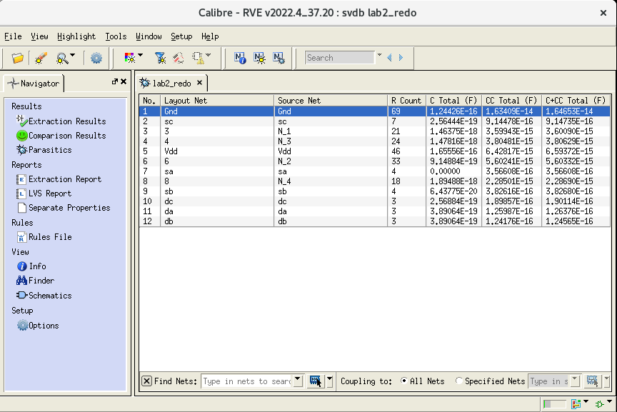
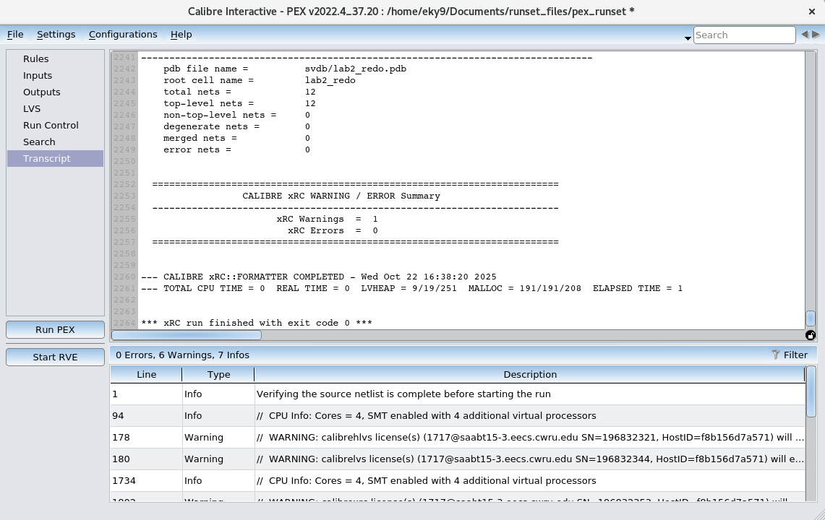

Instead of the full PEX Report, I have copied and pasted the .pxi file and .pex.netlist files for this lab below:

.PXI FILE
* File: lab2_redo.pex.netlist.lab2_redo.pxi
* Created: Wed Oct 22 16:38:19 2025
*
x_PM_lab2_redo_Gnd N_Gnd_MMn6_b N_Gnd_c_53_p N_Gnd_c_4_p N_Gnd_MMn1_s
+ N_Gnd_c_65_p N_Gnd_c_17_p N_Gnd_MMn3_s N_Gnd_c_15_p N_Gnd_MMn2_s N_Gnd_c_104_p
+ N_Gnd_c_132_p N_Gnd_c_139_p N_Gnd_c_105_p N_Gnd_c_160_p Gnd N_Gnd_c_39_p
+ N_Gnd_c_47_p N_Gnd_c_66_p N_Gnd_c_7_p N_Gnd_c_44_p N_Gnd_c_19_p N_Gnd_c_31_p
+ N_Gnd_c_115_p N_Gnd_c_13_p N_Gnd_c_128_p N_Gnd_c_85_p N_Gnd_c_135_p
+ N_Gnd_c_141_p N_Gnd_c_142_p N_Gnd_c_20_p N_Gnd_c_161_p N_Gnd_c_166_p
+ N_Gnd_c_2_p N_Gnd_c_121_p N_Gnd_c_8_p N_Gnd_c_9_p N_Gnd_c_23_p
+ PM_lab2_redo_Gnd
x_PM_lab2_redo_sc N_sc_MMp4_g N_sc_MMn6_g N_sc_c_196_n sc N_sc_c_197_n
+ PM_lab2_redo_sc
x_PM_lab2_redo_N_1 N_N_1_MMp4_d N_N_1_c_243_n N_N_1_c_219_n N_N_1_MMp3_d
+ N_N_1_c_256_p N_N_1_MMn3_d N_N_1_c_221_n N_N_1_c_223_n N_N_1_c_257_p
+ N_N_1_c_246_n N_N_1_c_225_n N_N_1_c_233_n N_N_1_c_235_n N_N_1_c_236_n
+ N_N_1_c_237_n N_N_1_c_238_n N_N_1_c_239_n PM_lab2_redo_N_1
x_PM_lab2_redo_N_3 N_N_3_MMp4_s N_N_3_c_283_n N_N_3_MMp1_g N_N_3_MMn6_d
+ N_N_3_c_285_n N_N_3_c_286_n N_N_3_MMn1_g N_N_3_c_294_n N_N_3_c_297_n
+ N_N_3_c_301_n N_N_3_c_306_n N_N_3_c_307_n N_N_3_c_310_n N_N_3_c_331_n
+ N_N_3_c_311_n N_N_3_c_313_n N_N_3_c_317_n PM_lab2_redo_N_3
x_PM_lab2_redo_Vdd N_Vdd_MMp4_b N_Vdd_c_395_n N_Vdd_c_361_n N_Vdd_MMp1_b
+ N_Vdd_c_402_n N_Vdd_MMp1_s N_Vdd_MMp3_b N_Vdd_c_427_p N_Vdd_MMp3_s
+ N_Vdd_MMp2_b N_Vdd_c_428_p N_Vdd_MMp2_s Vdd N_Vdd_c_363_n N_Vdd_c_365_n
+ N_Vdd_c_368_n N_Vdd_c_369_n N_Vdd_c_370_n N_Vdd_c_371_n N_Vdd_c_408_n
+ N_Vdd_c_372_n N_Vdd_c_373_n N_Vdd_c_374_n N_Vdd_c_390_n N_Vdd_c_375_n
+ N_Vdd_c_376_n N_Vdd_c_377_n N_Vdd_c_422_p N_Vdd_c_378_n N_Vdd_c_379_n
+ N_Vdd_c_380_n PM_lab2_redo_Vdd
x_PM_lab2_redo_N_2 N_N_2_MMp1_d N_N_2_c_501_n N_N_2_c_433_n N_N_2_MMp3_g
+ N_N_2_MMp2_g N_N_2_MMn1_d N_N_2_c_436_n N_N_2_c_438_n N_N_2_MMn3_g
+ N_N_2_MMn2_g N_N_2_c_450_n N_N_2_c_453_n N_N_2_c_456_n N_N_2_c_457_n
+ N_N_2_c_461_n N_N_2_c_467_n N_N_2_c_470_n N_N_2_c_474_n N_N_2_c_477_n
+ N_N_2_c_478_n N_N_2_c_480_n N_N_2_c_481_n PM_lab2_redo_N_2
x_PM_lab2_redo_sa N_sa_MMn8_g N_sa_c_531_n sa PM_lab2_redo_sa
x_PM_lab2_redo_N_4 N_N_4_MMp2_d N_N_4_c_571_n N_N_4_c_546_n N_N_4_MMn2_d
+ N_N_4_c_547_n N_N_4_c_548_n N_N_4_MMn8_s N_N_4_c_555_n N_N_4_MMn5_s
+ N_N_4_c_561_n N_N_4_c_566_n N_N_4_c_567_n N_N_4_c_570_n PM_lab2_redo_N_4
x_PM_lab2_redo_sb N_sb_MMn5_g N_sb_c_593_n N_sb_c_596_n sb N_sb_c_599_n
+ PM_lab2_redo_sb
x_PM_lab2_redo_dc N_dc_MMn6_s N_dc_c_613_n dc PM_lab2_redo_dc
x_PM_lab2_redo_da N_da_MMn8_d N_da_c_623_n da PM_lab2_redo_da
x_PM_lab2_redo_db N_db_MMn5_d N_db_c_632_n db PM_lab2_redo_db
cc_1 N_Gnd_MMn6_b N_sc_MMp4_g 0.0792478f
cc_2 N_Gnd_c_2_p N_sc_MMp4_g 0.00576481f
cc_3 N_Gnd_MMn6_b N_sc_MMn6_g 0.17793f
cc_4 N_Gnd_c_4_p N_sc_MMn6_g 9.16727e-19
cc_5 N_Gnd_MMn6_b N_sc_c_196_n 0.0924455f
cc_6 N_Gnd_MMn6_b N_sc_c_197_n 0.025219f
cc_7 N_Gnd_c_7_p N_sc_c_197_n 0.00105327f
cc_8 N_Gnd_c_8_p N_sc_c_197_n 4.02556e-19
cc_9 N_Gnd_c_9_p N_sc_c_197_n 8.82033e-19
cc_10 N_Gnd_c_2_p N_N_1_c_219_n 0.00980167f
cc_11 N_Gnd_c_9_p N_N_1_c_219_n 0.00871362f
cc_12 N_Gnd_MMn6_b N_N_1_c_221_n 0.00100911f
cc_13 N_Gnd_c_13_p N_N_1_c_221_n 2.44265e-19
cc_14 N_Gnd_MMn3_s N_N_1_c_223_n 2.43033e-19
cc_15 N_Gnd_c_15_p N_N_1_c_223_n 0.0180039f
cc_16 N_Gnd_MMn6_b N_N_1_c_225_n 1.31178f
cc_17 N_Gnd_c_17_p N_N_1_c_225_n 0.00247107f
cc_18 N_Gnd_c_7_p N_N_1_c_225_n 0.00152127f
cc_19 N_Gnd_c_19_p N_N_1_c_225_n 0.00234313f
cc_20 N_Gnd_c_20_p N_N_1_c_225_n 0.0924204f
cc_21 N_Gnd_c_2_p N_N_1_c_225_n 0.0328492f
cc_22 N_Gnd_c_9_p N_N_1_c_225_n 0.185705f
cc_23 N_Gnd_c_23_p N_N_1_c_225_n 0.186447f
cc_24 N_Gnd_MMn6_b N_N_1_c_233_n 0.0683378f
cc_25 N_Gnd_c_13_p N_N_1_c_233_n 2.38849e-19
cc_26 N_Gnd_MMn6_b N_N_1_c_235_n 0.201815f
cc_27 N_Gnd_c_13_p N_N_1_c_236_n 0.0180039f
cc_28 N_Gnd_MMn6_b N_N_1_c_237_n 0.0415555f
cc_29 N_Gnd_MMn6_b N_N_1_c_238_n 0.0195596f
cc_30 N_Gnd_MMn6_b N_N_1_c_239_n 0.403775f
cc_31 N_Gnd_c_31_p N_N_1_c_239_n 0.00147035f
cc_32 N_Gnd_c_20_p N_N_1_c_239_n 0.00407466f
cc_33 N_Gnd_c_23_p N_N_1_c_239_n 0.0187435f
cc_34 N_Gnd_c_2_p N_N_3_c_283_n 0.0101871f
cc_35 N_Gnd_MMn6_b N_N_3_MMp1_g 0.0446685f
cc_36 N_Gnd_MMn6_b N_N_3_c_285_n 0.00100911f
cc_37 N_Gnd_MMn6_b N_N_3_c_286_n 0.107214f
cc_38 N_Gnd_c_17_p N_N_3_c_286_n 0.00808728f
cc_39 N_Gnd_c_39_p N_N_3_c_286_n 0.00106823f
cc_40 N_Gnd_c_7_p N_N_3_c_286_n 8.12527e-19
cc_41 N_Gnd_MMn6_b N_N_3_MMn1_g 0.202336f
cc_42 N_Gnd_MMn1_s N_N_3_MMn1_g 0.00327009f
cc_43 N_Gnd_c_7_p N_N_3_MMn1_g 0.0342351f
cc_44 N_Gnd_c_44_p N_N_3_MMn1_g 0.0260977f
cc_45 N_Gnd_MMn6_b N_N_3_c_294_n 0.0991017f
cc_46 N_Gnd_MMn1_s N_N_3_c_294_n 0.00564271f
cc_47 N_Gnd_c_47_p N_N_3_c_294_n 0.00185317f
cc_48 N_Gnd_MMn6_b N_N_3_c_297_n 0.256493f
cc_49 N_Gnd_c_4_p N_N_3_c_297_n 0.00155998f
cc_50 N_Gnd_c_39_p N_N_3_c_297_n 0.00676136f
cc_51 N_Gnd_c_8_p N_N_3_c_297_n 0.0371682f
cc_52 N_Gnd_MMn6_b N_N_3_c_301_n 0.418788f
cc_53 N_Gnd_c_53_p N_N_3_c_301_n 0.00533646f
cc_54 N_Gnd_c_4_p N_N_3_c_301_n 0.0131076f
cc_55 N_Gnd_c_39_p N_N_3_c_301_n 0.0212879f
cc_56 N_Gnd_c_8_p N_N_3_c_301_n 0.155079f
cc_57 N_Gnd_MMn6_b N_N_3_c_306_n 0.0419753f
cc_58 N_Gnd_MMn6_b N_N_3_c_307_n 0.538788f
cc_59 N_Gnd_c_39_p N_N_3_c_307_n 0.040714f
cc_60 N_Gnd_c_8_p N_N_3_c_307_n 0.00670317f
cc_61 N_Gnd_MMn6_b N_N_3_c_310_n 0.0498712f
cc_62 N_Gnd_MMn6_b N_N_3_c_311_n 0.0647637f
cc_63 N_Gnd_c_8_p N_N_3_c_311_n 0.0127279f
cc_64 N_Gnd_MMn6_b N_N_3_c_313_n 0.369346f
cc_65 N_Gnd_c_65_p N_N_3_c_313_n 9.07082e-19
cc_66 N_Gnd_c_66_p N_N_3_c_313_n 0.0229526f
cc_67 N_Gnd_c_9_p N_N_3_c_313_n 0.00123506f
cc_68 N_Gnd_MMn6_b N_N_3_c_317_n 0.0348036f
cc_69 N_Gnd_c_2_p N_Vdd_c_361_n 0.00977933f
cc_70 N_Gnd_c_8_p N_Vdd_c_361_n 0.0176076f
cc_71 N_Gnd_MMn6_b N_Vdd_c_363_n 1.22438f
cc_72 N_Gnd_c_8_p N_Vdd_c_363_n 0.02656f
cc_73 N_Gnd_MMn6_b N_Vdd_c_365_n 0.336793f
cc_74 N_Gnd_c_2_p N_Vdd_c_365_n 0.0161004f
cc_75 N_Gnd_c_8_p N_Vdd_c_365_n 0.14156f
cc_76 N_Gnd_MMn6_b N_Vdd_c_368_n 0.0832676f
cc_77 N_Gnd_MMn6_b N_Vdd_c_369_n 1.07534f
cc_78 N_Gnd_MMn6_b N_Vdd_c_370_n 0.0839006f
cc_79 N_Gnd_c_47_p N_Vdd_c_371_n 7.97104e-19
cc_80 N_Gnd_MMn6_b N_Vdd_c_372_n 0.0703538f
cc_81 N_Gnd_MMn6_b N_Vdd_c_373_n 0.68707f
cc_82 N_Gnd_c_13_p N_Vdd_c_374_n 7.72393e-19
cc_83 N_Gnd_MMn6_b N_Vdd_c_375_n 0.063164f
cc_84 N_Gnd_MMn6_b N_Vdd_c_376_n 0.774632f
cc_85 N_Gnd_c_85_p N_Vdd_c_377_n 6.02744e-19
cc_86 N_Gnd_MMn6_b N_Vdd_c_378_n 0.0241335f
cc_87 N_Gnd_MMn6_b N_Vdd_c_379_n 0.0328215f
cc_88 N_Gnd_MMn6_b N_Vdd_c_380_n 0.0327844f
cc_89 N_Gnd_MMn6_b N_N_2_c_433_n 0.040988f
cc_90 N_Gnd_MMn6_b N_N_2_MMp3_g 0.0507707f
cc_91 N_Gnd_MMn6_b N_N_2_MMp2_g 0.0540252f
cc_92 N_Gnd_MMn6_b N_N_2_c_436_n 0.00201822f
cc_93 N_Gnd_c_65_p N_N_2_c_436_n 2.00063e-19
cc_94 N_Gnd_MMn6_b N_N_2_c_438_n 0.0748524f
cc_95 N_Gnd_MMn1_s N_N_2_c_438_n 3.64549e-19
cc_96 N_Gnd_c_7_p N_N_2_c_438_n 0.0152659f
cc_97 N_Gnd_c_44_p N_N_2_c_438_n 0.023081f
cc_98 N_Gnd_MMn6_b N_N_2_MMn3_g 0.183006f
cc_99 N_Gnd_MMn3_s N_N_2_MMn3_g 0.00830532f
cc_100 N_Gnd_c_15_p N_N_2_MMn3_g 0.03757f
cc_101 N_Gnd_c_31_p N_N_2_MMn3_g 0.00259678f
cc_102 N_Gnd_MMn6_b N_N_2_MMn2_g 0.22425f
cc_103 N_Gnd_MMn2_s N_N_2_MMn2_g 0.00408761f
cc_104 N_Gnd_c_104_p N_N_2_MMn2_g 0.0533672f
cc_105 N_Gnd_c_105_p N_N_2_MMn2_g 0.00382771f
cc_106 N_Gnd_MMn6_b N_N_2_c_450_n 0.0991017f
cc_107 N_Gnd_MMn3_s N_N_2_c_450_n 0.00584112f
cc_108 N_Gnd_c_13_p N_N_2_c_450_n 0.00190038f
cc_109 N_Gnd_MMn6_b N_N_2_c_453_n 0.0991017f
cc_110 N_Gnd_MMn2_s N_N_2_c_453_n 0.0038595f
cc_111 N_Gnd_c_85_p N_N_2_c_453_n 0.00137322f
cc_112 N_Gnd_MMn6_b N_N_2_c_456_n 0.242977f
cc_113 N_Gnd_MMn6_b N_N_2_c_457_n 0.321757f
cc_114 N_Gnd_c_19_p N_N_2_c_457_n 0.0154712f
cc_115 N_Gnd_c_115_p N_N_2_c_457_n 0.00708582f
cc_116 N_Gnd_c_23_p N_N_2_c_457_n 0.0464285f
cc_117 N_Gnd_MMn6_b N_N_2_c_461_n 0.693173f
cc_118 N_Gnd_c_15_p N_N_2_c_461_n 0.0101383f
cc_119 N_Gnd_c_19_p N_N_2_c_461_n 0.030428f
cc_120 N_Gnd_c_13_p N_N_2_c_461_n 0.00306901f
cc_121 N_Gnd_c_121_p N_N_2_c_461_n 0.00400964f
cc_122 N_Gnd_c_23_p N_N_2_c_461_n 0.159091f
cc_123 N_Gnd_MMn6_b N_N_2_c_467_n 0.0556416f
cc_124 N_Gnd_c_7_p N_N_2_c_467_n 0.00564321f
cc_125 N_Gnd_c_9_p N_N_2_c_467_n 3.19873e-19
cc_126 N_Gnd_MMn6_b N_N_2_c_470_n 0.310749f
cc_127 N_Gnd_c_19_p N_N_2_c_470_n 0.00961631f
cc_128 N_Gnd_c_128_p N_N_2_c_470_n 0.0229971f
cc_129 N_Gnd_c_23_p N_N_2_c_470_n 0.00354458f
cc_130 N_Gnd_MMn6_b N_N_2_c_474_n 0.367316f
cc_131 N_Gnd_c_104_p N_N_2_c_474_n 0.00400964f
cc_132 N_Gnd_c_132_p N_N_2_c_474_n 0.011487f
cc_133 N_Gnd_MMn6_b N_N_2_c_477_n 0.059785f
cc_134 N_Gnd_MMn6_b N_N_2_c_478_n 0.307981f
cc_135 N_Gnd_c_135_p N_N_2_c_478_n 0.016066f
cc_136 N_Gnd_MMn6_b N_N_2_c_480_n 0.0160891f
cc_137 N_Gnd_MMn6_b N_N_2_c_481_n 0.0433617f
cc_138 N_Gnd_MMn6_b N_sa_c_531_n 0.170188f
cc_139 N_Gnd_c_139_p N_sa_c_531_n 0.00550409f
cc_140 N_Gnd_c_105_p N_sa_c_531_n 0.00849389f
cc_141 N_Gnd_c_141_p N_sa_c_531_n 0.00237041f
cc_142 N_Gnd_c_142_p N_sa_c_531_n 0.00176595f
cc_143 N_Gnd_MMn6_b sa 0.0246343f
cc_144 N_Gnd_c_105_p sa 0.00631957f
cc_145 N_Gnd_c_141_p sa 0.00456943f
cc_146 N_Gnd_c_142_p sa 0.00332206f
cc_147 N_Gnd_MMn6_b N_N_4_c_546_n 0.0486135f
cc_148 N_Gnd_MMn6_b N_N_4_c_547_n 0.00201822f
cc_149 N_Gnd_MMn6_b N_N_4_c_548_n 0.112021f
cc_150 N_Gnd_MMn2_s N_N_4_c_548_n 2.43033e-19
cc_151 N_Gnd_c_104_p N_N_4_c_548_n 0.0342231f
cc_152 N_Gnd_c_105_p N_N_4_c_548_n 0.00739266f
cc_153 N_Gnd_MMn6_b N_N_4_MMn8_s 0.00201822f
cc_154 N_Gnd_c_139_p N_N_4_MMn8_s 0.0188997f
cc_155 N_Gnd_c_105_p N_N_4_MMn8_s 0.00387364f
cc_156 N_Gnd_c_139_p N_N_4_c_555_n 0.00393655f
cc_157 N_Gnd_c_105_p N_N_4_c_555_n 0.0341948f
cc_158 N_Gnd_c_141_p N_N_4_c_555_n 0.00349912f
cc_159 N_Gnd_MMn6_b N_N_4_MMn5_s 0.00201822f
cc_160 N_Gnd_c_160_p N_N_4_MMn5_s 0.0188997f
cc_161 N_Gnd_c_161_p N_N_4_MMn5_s 0.00387364f
cc_162 N_Gnd_MMn6_b N_N_4_c_561_n 0.210622f
cc_163 N_Gnd_c_160_p N_N_4_c_561_n 0.00393657f
cc_164 N_Gnd_c_142_p N_N_4_c_561_n 0.0167492f
cc_165 N_Gnd_c_161_p N_N_4_c_561_n 0.0341952f
cc_166 N_Gnd_c_166_p N_N_4_c_561_n 0.00214909f
cc_167 N_Gnd_MMn6_b N_N_4_c_566_n 0.465526f
cc_168 N_Gnd_MMn6_b N_N_4_c_567_n 0.566597f
cc_169 N_Gnd_c_105_p N_N_4_c_567_n 0.0118051f
cc_170 N_Gnd_c_161_p N_N_4_c_567_n 0.00839826f
cc_171 N_Gnd_MMn6_b N_N_4_c_570_n 0.016127f
cc_172 N_Gnd_MMn6_b N_sb_c_593_n 0.0699992f
cc_173 N_Gnd_c_142_p N_sb_c_593_n 0.00173799f
cc_174 N_Gnd_c_161_p N_sb_c_593_n 0.00370825f
cc_175 N_Gnd_MMn6_b N_sb_c_596_n 0.128373f
cc_176 N_Gnd_c_160_p N_sb_c_596_n 0.00550409f
cc_177 N_Gnd_c_161_p N_sb_c_596_n 0.00488834f
cc_178 N_Gnd_MMn6_b N_sb_c_599_n 0.0263801f
cc_179 N_Gnd_c_142_p N_sb_c_599_n 0.00327309f
cc_180 N_Gnd_c_161_p N_sb_c_599_n 0.00647109f
cc_181 N_Gnd_c_166_p N_sb_c_599_n 0.00282399f
cc_182 N_Gnd_c_53_p N_dc_MMn6_s 0.0194867f
cc_183 N_Gnd_c_4_p N_dc_MMn6_s 0.00378253f
cc_184 N_Gnd_c_53_p N_dc_c_613_n 0.00346607f
cc_185 N_Gnd_c_4_p N_dc_c_613_n 0.0388543f
cc_186 N_Gnd_MMn6_b N_da_c_623_n 0.00302733f
cc_187 N_Gnd_c_141_p da 0.00336762f
cc_188 N_Gnd_c_142_p da 0.0150289f
cc_189 N_Gnd_MMn6_b N_db_c_632_n 0.00302733f
cc_190 N_Gnd_c_142_p db 0.0150289f
cc_191 N_Gnd_c_166_p db 0.00230655f
cc_192 N_sc_MMp4_g N_N_1_c_243_n 0.0039541f
cc_193 N_sc_c_196_n N_N_1_c_243_n 0.00342081f
cc_194 N_sc_MMp4_g N_N_1_c_219_n 0.0377948f
cc_195 N_sc_c_196_n N_N_1_c_246_n 0.00126921f
cc_196 N_sc_c_197_n N_N_1_c_246_n 0.00295346f
cc_197 N_sc_MMp4_g N_N_3_MMp4_s 0.0039541f
cc_198 N_sc_MMp4_g N_N_3_c_283_n 0.0662736f
cc_199 N_sc_MMn6_g N_N_3_c_285_n 0.0175592f
cc_200 N_sc_c_196_n N_N_3_c_285_n 0.0107956f
cc_201 N_sc_MMn6_g N_N_3_c_286_n 0.0527436f
cc_202 N_sc_c_196_n N_N_3_c_286_n 0.00244985f
cc_203 N_sc_c_197_n N_N_3_c_286_n 0.00800127f
cc_204 N_sc_c_197_n N_N_3_c_301_n 0.019731f
cc_205 N_sc_MMn6_g N_N_3_c_307_n 0.00443347f
cc_206 N_sc_c_196_n N_N_3_c_311_n 0.0662736f
cc_207 N_sc_MMp4_g N_Vdd_MMp4_b 0.170473f
cc_208 N_sc_MMn6_g N_dc_MMn6_s 0.0216468f
cc_209 N_sc_MMn6_g N_dc_c_613_n 0.0368899f
cc_210 N_N_1_c_246_n N_N_3_MMp4_s 2.45515e-19
cc_211 N_N_1_c_219_n N_N_3_c_283_n 0.0193057f
cc_212 N_N_1_c_246_n N_N_3_c_286_n 9.97452e-19
cc_213 N_N_1_c_246_n N_N_3_c_331_n 0.0193057f
cc_214 N_N_1_c_243_n N_Vdd_MMp4_b 0.00201822f
cc_215 N_N_1_c_219_n N_Vdd_MMp4_b 0.0230517f
cc_216 N_N_1_c_246_n N_Vdd_MMp4_b 0.0105443f
cc_217 N_N_1_c_225_n N_Vdd_MMp4_b 0.0762264f
cc_218 N_N_1_c_256_p N_Vdd_MMp3_b 0.00100911f
cc_219 N_N_1_c_257_p N_Vdd_MMp3_b 0.0403621f
cc_220 N_N_1_c_237_n N_Vdd_MMp3_b 0.0535687f
cc_221 N_N_1_c_257_p N_Vdd_MMp3_s 2.43033e-19
cc_222 N_N_1_c_256_p N_Vdd_c_390_n 2.44265e-19
cc_223 N_N_1_c_257_p N_Vdd_c_390_n 0.0177589f
cc_224 N_N_1_c_257_p N_Vdd_c_375_n 0.0177589f
cc_225 N_N_1_c_257_p N_Vdd_c_376_n 0.00666885f
cc_226 N_N_1_c_256_p N_N_2_MMp3_g 0.0176927f
cc_227 N_N_1_c_257_p N_N_2_MMp3_g 0.03688f
cc_228 N_N_1_c_237_n N_N_2_MMp3_g 0.042328f
cc_229 N_N_1_c_225_n N_N_2_c_438_n 0.00254736f
cc_230 N_N_1_c_221_n N_N_2_MMn3_g 0.0182316f
cc_231 N_N_1_c_223_n N_N_2_MMn3_g 0.03688f
cc_232 N_N_1_c_233_n N_N_2_MMn3_g 0.042328f
cc_233 N_N_1_c_239_n N_N_2_MMn3_g 0.00250922f
cc_234 N_N_1_c_238_n N_N_2_c_450_n 0.0423607f
cc_235 N_N_1_c_223_n N_N_2_c_461_n 0.0107369f
cc_236 N_N_1_c_235_n N_N_2_c_461_n 0.00510231f
cc_237 N_N_1_c_239_n N_N_2_c_461_n 0.164179f
cc_238 N_N_1_c_225_n N_N_2_c_467_n 0.0697122f
cc_239 N_N_1_c_238_n N_N_2_c_470_n 0.0330613f
cc_240 N_N_1_c_239_n N_N_2_c_470_n 0.00132292f
cc_241 N_N_1_c_223_n N_N_2_c_474_n 0.00802694f
cc_242 N_N_1_c_235_n N_N_2_c_474_n 0.00735836f
cc_243 N_N_1_c_239_n N_N_2_c_474_n 0.0867143f
cc_244 N_N_1_c_237_n N_N_2_c_477_n 0.00162894f
cc_245 N_N_3_c_311_n N_Vdd_MMp4_b 0.0473236f
cc_246 N_N_3_MMp4_s N_Vdd_c_395_n 0.0195046f
cc_247 N_N_3_c_283_n N_Vdd_c_395_n 0.00224473f
cc_248 N_N_3_c_331_n N_Vdd_c_395_n 0.00180462f
cc_249 N_N_3_MMp4_s N_Vdd_c_361_n 0.00342106f
cc_250 N_N_3_c_283_n N_Vdd_c_361_n 0.0231404f
cc_251 N_N_3_c_331_n N_Vdd_c_361_n 0.00723118f
cc_252 N_N_3_MMp1_g N_Vdd_MMp1_b 0.156393f
cc_253 N_N_3_c_313_n N_Vdd_c_402_n 0.0203013f
cc_254 N_N_3_MMp1_g N_Vdd_MMp1_s 0.00408761f
cc_255 N_N_3_c_294_n N_Vdd_MMp1_s 0.00493408f
cc_256 N_N_3_c_306_n N_Vdd_c_363_n 0.129215f
cc_257 N_N_3_c_306_n N_Vdd_c_365_n 0.0380272f
cc_258 N_N_3_c_311_n N_Vdd_c_365_n 0.00723118f
cc_259 N_N_3_MMp1_g N_Vdd_c_408_n 0.0533682f
cc_260 N_N_3_c_294_n N_Vdd_c_408_n 0.00165322f
cc_261 N_N_3_MMp1_g N_Vdd_c_373_n 0.00314417f
cc_262 N_N_3_MMp1_g N_N_2_c_501_n 0.0176927f
cc_263 N_N_3_MMp1_g N_N_2_c_433_n 0.0693566f
cc_264 N_N_3_MMn1_g N_N_2_c_436_n 0.0176927f
cc_265 N_N_3_MMn1_g N_N_2_c_438_n 0.0693566f
cc_266 N_N_3_c_294_n N_N_2_c_480_n 0.0693902f
cc_267 N_N_3_c_313_n N_N_2_c_480_n 0.0345486f
cc_268 N_N_3_c_286_n N_dc_MMn6_s 2.44022e-19
cc_269 N_N_3_c_301_n N_dc_MMn6_s 0.00729808f
cc_270 N_N_3_c_285_n N_dc_c_613_n 2.44022e-19
cc_271 N_N_3_c_286_n N_dc_c_613_n 0.0343158f
cc_272 N_N_3_c_301_n N_dc_c_613_n 0.015753f
cc_273 N_N_3_c_307_n N_dc_c_613_n 0.00787602f
cc_274 N_Vdd_MMp1_b N_N_2_c_501_n 0.00201822f
cc_275 N_Vdd_MMp1_b N_N_2_c_433_n 0.0941223f
cc_276 N_Vdd_MMp1_s N_N_2_c_433_n 2.43033e-19
cc_277 N_Vdd_c_408_n N_N_2_c_433_n 0.034225f
cc_278 N_Vdd_c_373_n N_N_2_c_433_n 0.00648209f
cc_279 N_Vdd_MMp3_b N_N_2_MMp3_g 0.156393f
cc_280 N_Vdd_MMp3_s N_N_2_MMp3_g 0.00408761f
cc_281 N_Vdd_c_390_n N_N_2_MMp3_g 0.0533672f
cc_282 N_Vdd_c_376_n N_N_2_MMp3_g 0.00336631f
cc_283 N_Vdd_MMp2_b N_N_2_MMp2_g 0.170279f
cc_284 N_Vdd_MMp2_s N_N_2_MMp2_g 0.00408761f
cc_285 N_Vdd_c_422_p N_N_2_MMp2_g 0.0533672f
cc_286 N_Vdd_MMp3_s N_N_2_c_450_n 0.00462524f
cc_287 N_Vdd_c_390_n N_N_2_c_450_n 0.00157259f
cc_288 N_Vdd_MMp2_s N_N_2_c_453_n 0.0044685f
cc_289 N_Vdd_c_422_p N_N_2_c_453_n 0.0015318f
cc_290 N_Vdd_c_427_p N_N_2_c_470_n 0.0188848f
cc_291 N_Vdd_c_428_p N_N_2_c_478_n 0.0182341f
cc_292 N_Vdd_MMp2_b N_N_4_c_571_n 0.00302733f
cc_293 N_Vdd_MMp2_b N_N_4_c_546_n 0.112636f
cc_294 N_Vdd_MMp2_s N_N_4_c_546_n 2.43033e-19
cc_295 N_Vdd_c_422_p N_N_4_c_546_n 0.0355304f
cc_296 N_N_2_MMp2_g N_N_4_c_571_n 0.0176927f
cc_297 N_N_2_MMp2_g N_N_4_c_546_n 0.0783626f
cc_298 N_N_2_MMn2_g N_N_4_c_547_n 0.0176927f
cc_299 N_N_2_MMn2_g N_N_4_c_548_n 0.0783626f
cc_300 N_N_2_c_478_n N_N_4_c_548_n 0.0349168f
cc_301 N_N_2_c_453_n N_N_4_c_570_n 0.0783961f
cc_302 N_sa_c_531_n N_N_4_MMn8_s 0.00895011f
cc_303 N_sa_c_531_n N_N_4_c_555_n 0.025286f
cc_304 N_sa_c_531_n N_N_4_c_561_n 0.0276838f
cc_305 N_sa_c_531_n N_sb_c_596_n 0.00238595f
cc_306 N_sa_c_531_n N_da_c_623_n 0.0277222f
cc_307 N_sa_c_531_n da 0.0374115f
cc_308 N_N_4_MMn5_s N_sb_c_593_n 0.0054459f
cc_309 N_N_4_c_561_n N_sb_c_593_n 3.1632e-19
cc_310 N_N_4_MMn5_s N_sb_c_596_n 0.0039541f
cc_311 N_N_4_c_561_n N_sb_c_596_n 0.0529773f
cc_312 N_N_4_MMn8_s da 2.43033e-19
cc_313 N_N_4_c_555_n da 0.0230766f
cc_314 N_N_4_c_561_n da 0.0125282f
cc_315 N_N_4_MMn5_s db 2.43033e-19
cc_316 N_N_4_c_561_n db 0.0356108f
cc_317 N_sb_c_593_n N_db_c_632_n 0.00519339f
cc_318 N_sb_c_596_n N_db_c_632_n 0.0223192f
cc_319 N_sb_c_596_n db 0.0368648f
cc_320 da db 0.00358171f

.PEX.NETLIST FILE
* File: lab2_redo.pex.netlist
* Created: Wed Oct 22 16:29:01 2025
* Program "Calibre xRC"
* Version "v2022.4_37.20"
*
.include "lab2_redo.pex.netlist.pex"
.subckt lab2_redo da db dc sa sb sc Gnd Vdd
*
* db db
* da da
* dc dc
* sb sb
* sa sa
* Vdd Vdd
* sc sc
* Gnd Gnd
XMMp4 N_N_1_MMp4_d N_sc_MMp4_g N_N_3_MMp4_s N_Vdd_MMp4_b PMOS25 L=2.5e-07
+ W=1.5e-06 AD=9.75e-13 AS=9.75e-13 PD=4.3e-06 PS=4.3e-06
XMMp1 N_N_2_MMp1_d N_N_3_MMp1_g N_Vdd_MMp1_s N_Vdd_MMp1_b PMOS25 L=2.5e-07
+ W=1.5e-06 AD=9.75e-13 AS=9.75e-13 PD=4.3e-06 PS=4.3e-06
XMMp3 N_N_1_MMp3_d N_N_2_MMp3_g N_Vdd_MMp3_s N_Vdd_MMp3_b PMOS25 L=2.5e-07
+ W=1.5e-06 AD=9.75e-13 AS=9.75e-13 PD=4.3e-06 PS=4.3e-06
XMMp2 N_N_4_MMp2_d N_N_2_MMp2_g N_Vdd_MMp2_s N_Vdd_MMp2_b PMOS25 L=2.5e-07
+ W=1.5e-06 AD=9.75e-13 AS=9.75e-13 PD=4.3e-06 PS=4.3e-06
XMMn6 N_N_3_MMn6_d N_sc_MMn6_g N_dc_MMn6_s N_Gnd_MMn6_b NMOS25 L=2.5e-07
+ W=1.5e-06 AD=9.75e-13 AS=9.75e-13 PD=4.3e-06 PS=4.3e-06
XMMn1 N_N_2_MMn1_d N_N_3_MMn1_g N_Gnd_MMn1_s N_Gnd_MMn6_b NMOS25 L=2.5e-07
+ W=1.5e-06 AD=9.75e-13 AS=9.75e-13 PD=4.3e-06 PS=4.3e-06
XMMn3 N_N_1_MMn3_d N_N_2_MMn3_g N_Gnd_MMn3_s N_Gnd_MMn6_b NMOS25 L=2.5e-07
+ W=1.5e-06 AD=9.75e-13 AS=9.75e-13 PD=4.3e-06 PS=4.3e-06
XMMn2 N_N_4_MMn2_d N_N_2_MMn2_g N_Gnd_MMn2_s N_Gnd_MMn6_b NMOS25 L=2.5e-07
+ W=1.5e-06 AD=9.75e-13 AS=9.75e-13 PD=4.3e-06 PS=4.3e-06
XMMn8 N_da_MMn8_d N_sa_MMn8_g N_N_4_MMn8_s N_Gnd_MMn6_b NMOS25 L=2.5e-07
+ W=1.5e-06 AD=9.75e-13 AS=9.75e-13 PD=4.3e-06 PS=4.3e-06
XMMn5 N_db_MMn5_d N_sb_MMn5_g N_N_4_MMn5_s N_Gnd_MMn6_b NMOS25 L=2.5e-07
+ W=1.5e-06 AD=9.75e-13 AS=9.75e-13 PD=4.3e-06 PS=4.3e-06
*
.include "lab2_redo.pex.netlist.lab2_redo.pxi"
*
.ends
*
*

Simulation of the extracted layout circuit
Now that I have the PEX data, I can use it to simulate the original circuit again to now account for parasitic capacitances that would exist in real world scenarios. I will paste the updated .pex.netlist file that I used to simulate this after all of the waveforms. For the following images, I will show the original waveform first, and then its corresponding waveform that takes into account parasitic capacitances, below.

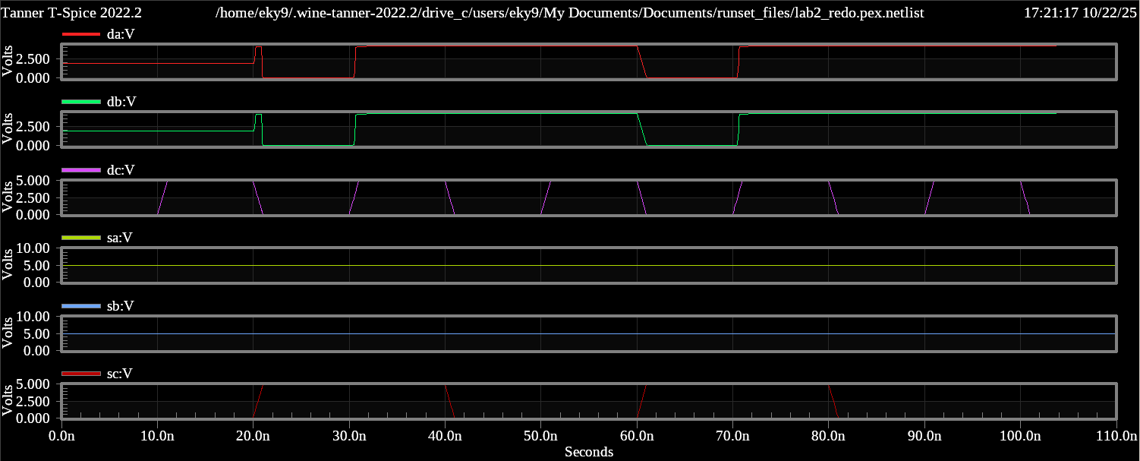

There is parasitic capacitance at the end of the inverters from gate-to-drain capacitance, which is likely the reason for the sudden spike in voltage in the lower waveform.

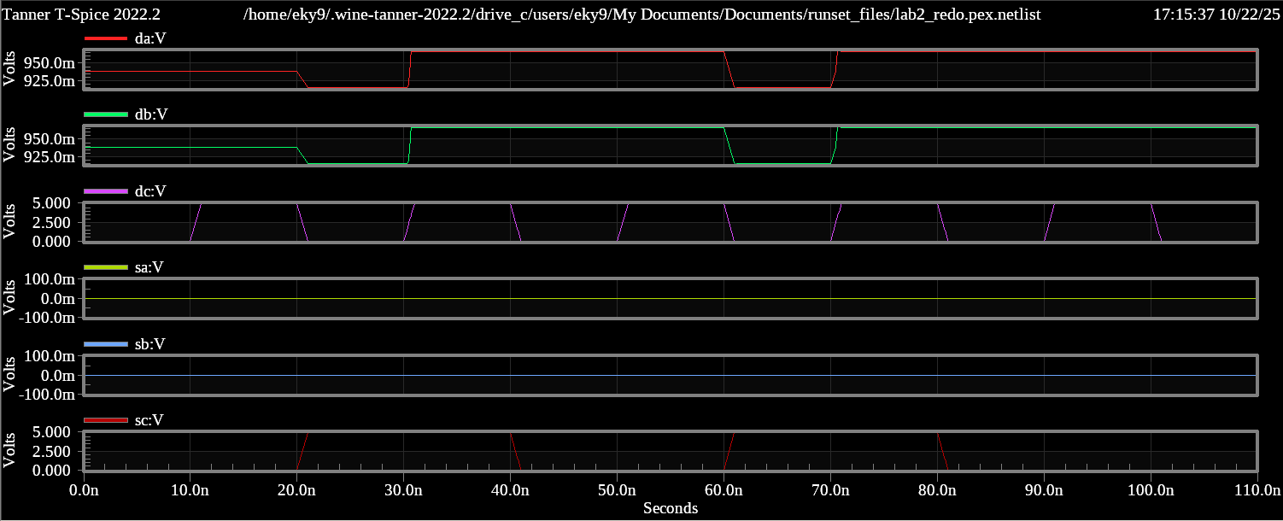

NMOS passes weak 1, which is why the top waveform shows a little bit of voltage. The waveform on the bottom shows more discrete values because the parasitic capacitances from the inverters supply more voltage to both outputs.

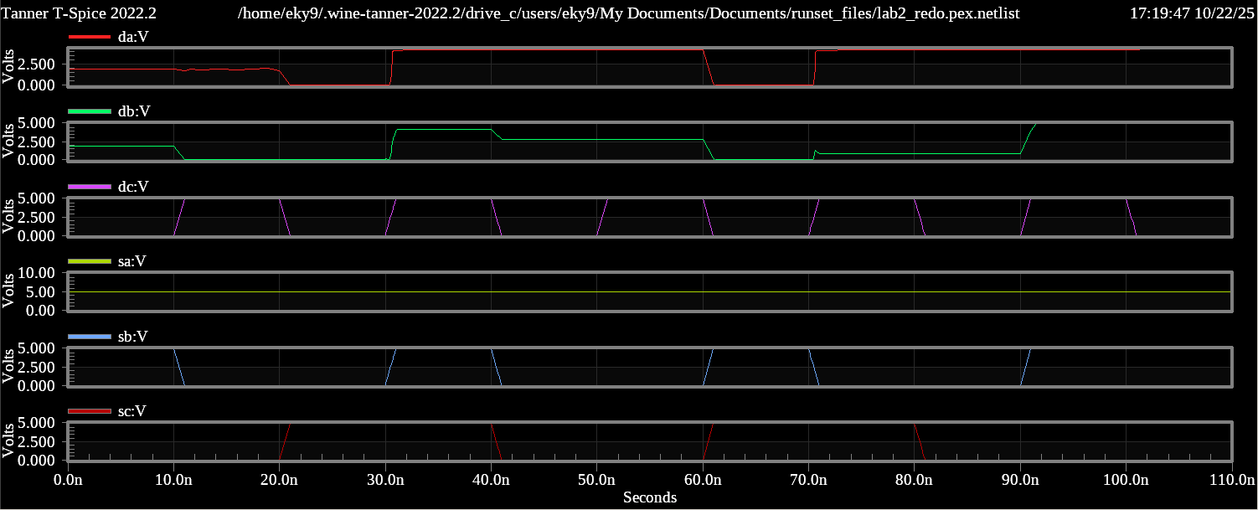

There is not much difference here, just a slight difference at 60ns. This specific configuration must mitigate the effects of the parasitic capacitances quite well.

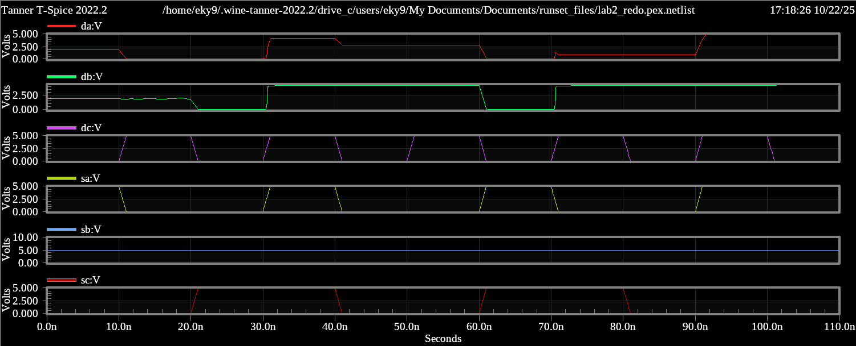

da goes to 0 when sa goes low which makes sense, and db goes to 0 when sc turns on and dc turns off. This makes sense given the schematic, and the only reason they were floating in the beginning was again due to the parasitic capacitances coming from the outputs of the inverters.

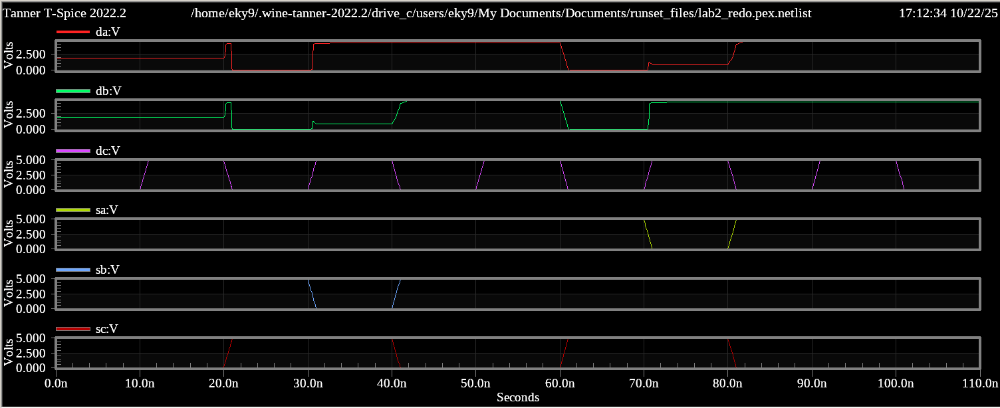

Similar to the very first waveform, the jump in voltage occurs when dc turns off and sc turns on, which is when the parasitic capacitance sitting at the end of the nearest inverter goes through to the outputs.

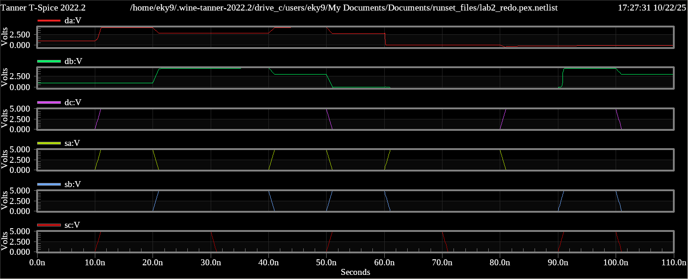

Due to the randomness of the inputs, the outputs were floating between 0V and 5V a lot of the time so the parasitic capacitances did not affect them much

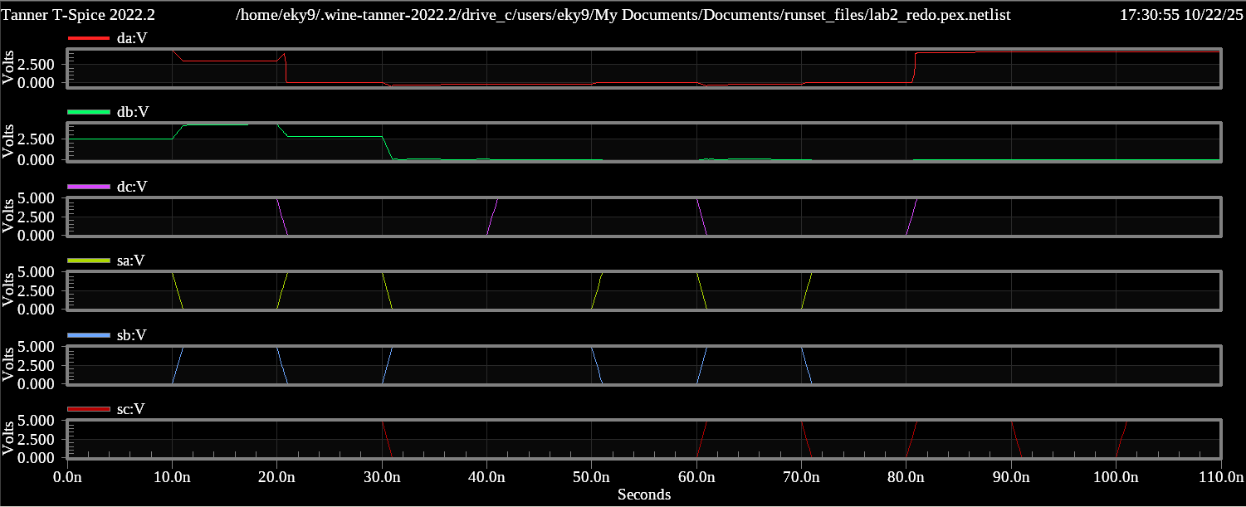

Similarly to the previous waveform, parasitic capacitances do not have much of an effect in these situations.

Updated .pex.netlist file for simulation
* File: lab2_redo.pex.netlist
* Created: Wed Oct 22 16:38:19 2025
* Program "Calibre xRC"
* Version "v2022.4_37.20"
*
.include "lab2_redo.pex.netlist.pex"
.INCLUDE "/home/eky9/TannerEDA/tspice.inc"
.LIB "/home/eky9/TannerEDA/TannerTools_v2022.2/Process/Generic_250nm/Models/spice/generic_250nm.lib" TT
.subckt lab2_redo da db dc sa sb sc Gnd Vdd
*
* db db
* da da
* dc dc
* sb sb
* sa sa
* Vdd Vdd
* sc sc
* Gnd Gnd
XMMp4 N_N_1_MMp4_d N_sc_MMp4_g N_N_3_MMp4_s N_Vdd_MMp4_b PMOS25 L=2.5e-07
+ W=1.5e-06 AD=9.75e-13 AS=9.75e-13 PD=4.3e-06 PS=4.3e-06
XMMp1 N_N_2_MMp1_d N_N_3_MMp1_g N_Vdd_MMp1_s N_Vdd_MMp1_b PMOS25 L=2.5e-07
+ W=1.5e-06 AD=9.75e-13 AS=9.75e-13 PD=4.3e-06 PS=4.3e-06
XMMp3 N_N_1_MMp3_d N_N_2_MMp3_g N_Vdd_MMp3_s N_Vdd_MMp3_b PMOS25 L=2.5e-07
+ W=1.5e-06 AD=9.75e-13 AS=9.75e-13 PD=4.3e-06 PS=4.3e-06
XMMp2 N_N_4_MMp2_d N_N_2_MMp2_g N_Vdd_MMp2_s N_Vdd_MMp2_b PMOS25 L=2.5e-07
+ W=1.5e-06 AD=9.75e-13 AS=9.75e-13 PD=4.3e-06 PS=4.3e-06
XMMn6 N_N_3_MMn6_d N_sc_MMn6_g N_dc_MMn6_s N_Gnd_MMn6_b NMOS25 L=2.5e-07
+ W=1.5e-06 AD=9.75e-13 AS=9.75e-13 PD=4.3e-06 PS=4.3e-06
XMMn1 N_N_2_MMn1_d N_N_3_MMn1_g N_Gnd_MMn1_s N_Gnd_MMn6_b NMOS25 L=2.5e-07
+ W=1.5e-06 AD=9.75e-13 AS=9.75e-13 PD=4.3e-06 PS=4.3e-06
XMMn3 N_N_1_MMn3_d N_N_2_MMn3_g N_Gnd_MMn3_s N_Gnd_MMn6_b NMOS25 L=2.5e-07
+ W=1.5e-06 AD=9.75e-13 AS=9.75e-13 PD=4.3e-06 PS=4.3e-06
XMMn2 N_N_4_MMn2_d N_N_2_MMn2_g N_Gnd_MMn2_s N_Gnd_MMn6_b NMOS25 L=2.5e-07
+ W=1.5e-06 AD=9.75e-13 AS=9.75e-13 PD=4.3e-06 PS=4.3e-06
XMMn8 N_da_MMn8_d N_sa_MMn8_g N_N_4_MMn8_s N_Gnd_MMn6_b NMOS25 L=2.5e-07
+ W=1.5e-06 AD=9.75e-13 AS=9.75e-13 PD=4.3e-06 PS=4.3e-06
XMMn5 N_db_MMn5_d N_sb_MMn5_g N_N_4_MMn5_s N_Gnd_MMn6_b NMOS25 L=2.5e-07
+ W=1.5e-06 AD=9.75e-13 AS=9.75e-13 PD=4.3e-06 PS=4.3e-06
*
.include "lab2_redo.pex.netlist.lab2_redo.pxi"
*
.ends
xDUT da db dc sa sb sc Gnd Vdd lab2_redo
VV5 Vdd Gnd DC 5 $ $x=5800 $y=2700 $w=400 $h=600
VV1 sc Gnd BIT({1110001010} ) $ $x=1300 $y=5200 $w=400 $h=600
VV2 dc Gnd BIT({1100110011} ) $ $x=2400 $y=4800 $w=400 $h=600
VV3 sa Gnd BIT({1010010111} ) $ $x=7700 $y=3200 $w=400 $h=600
VV4 sb Gnd BIT({0101101000} ) $ $x=9500 $y=3200 $w=400 $h=600
.PLOT V(da) $ $x=7150 $y=2550 $w=1500 $h=300 $r=180
.PLOT V(db) $ $x=9350 $y=1650 $w=300 $h=1500 $r=90
.PLOT V(dc) $ $x=2650 $y=5850 $w=300 $h=1500 $r=270
.PLOT V(sa) $ $x=8050 $y=4250 $w=300 $h=1500 $r=270
.PLOT V(sb) $ $x=9350 $y=4250 $w=300 $h=1500 $r=270
.PLOT V(sc) $ $x=1650 $y=6250 $w=300 $h=1500 $r=270
.TRAN 10n 110n
*
*

